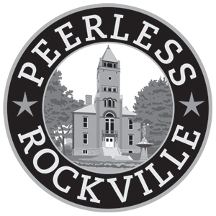
Celebrating 40 years of Preservation
in Rockville, Maryland

Peerless Rockville cordially invites you to our
40th Anniversary Celebration & Annual Meeting

Saturday, June 14, 2014 from 11 o’clock to 1 o’clock
on the front lawn of Frieda’s Cottage at Chestnut Lodge
19 Thomas Street, Rockville, Maryland

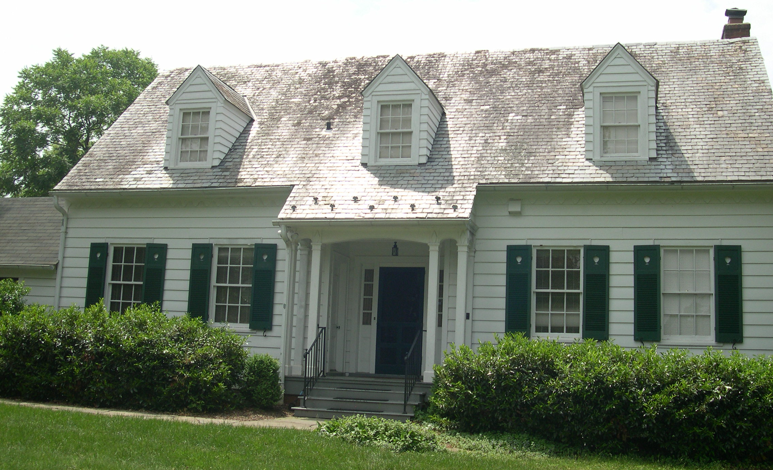

- Open House at Frieda’s Cottage
- Live music
- Light refreshments, cool beverages, anniversary cake
- Visit by Dr. Frieda Fromm-Reichmann, renowned psychotherapist at Chestnut Lodge 1935-1957
- Brief business meeting & election at 11 a.m.

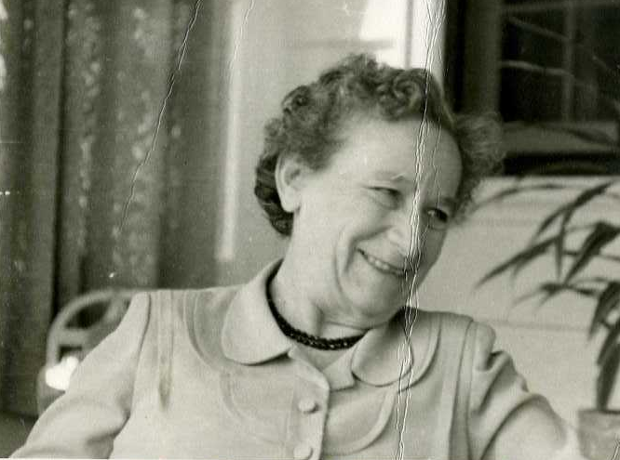

For more information: visit www.peerlessrockville.org
Questions? Call 301.762.0096 or email info@peerlessrockville.org

